ASTA 607
22424361
QUESTION 1
- Describing the data set using the one in package MASS
The crabs dataset in the MASS package contains measurements of 200 crabs, with 50 crabs from each of four different species. The dataset includes the following variables:
1. sp: Species of the crab (categorical variable with four levels)
2. index: Index number of the crab (integer)
3. FL: Frontal lobe size (numeric)
4. RW: Rear width (numeric)
5. CL: Carapace length (numeric)
6. CW: Carapace width (numeric)
7. BD: Body depth (numeric)

MASS::crabs
head(crabs)

head(crabs)
sp sex index FL RW CL CW BD
1 B M 1 8.1 6.7 16.1 19.0 7.0
2 B M 2 8.8 7.7 18.1 20.8 7.4
3 B M 3 9.2 7.8 19.0 22.4 7.7
4 B M 4 9.6 7.9 20.1 23.1 8.2
5 B M 5 9.8 8.0 20.3 23.0 8.2
6 B M 6 10.8 9.0 23.0 26.5 9.8

- Load the dataset and display its structure.
library(MASS)
data(crabs)
str(crabs)

data.frame': 200 obs. of 8 variables:
$ sp : Factor w/ 2 levels "B","O": 1 1 1 1 1 1 1 1 1 1 ...
$ sex : Factor w/ 2 levels "F","M": 2 2 2 2 2 2 2 2 2 2 ...
$ index: int 1 2 3 4 5 6 7 8 9 10 ...
$ FL : num 8.1 8.8 9.2 9.6 9.8 10.8 11.1 11.6 11.8 11.8 ...
$ RW : num 6.7 7.7 7.8 7.9 8 9 9.9 9.1 9.6 10.5 ...
$ CL : num 16.1 18.1 19 20.1 20.3 23 23.8 24.5 24.2 25.2 ...
$ CW : num 19 20.8 22.4 23.1 23 26.5 27.1 28.4 27.8 29.3 ...
$ BD : num 7 7.4 7.7 8.2 8.2 9.8 9.8 10.4 9.7 10.3 ...

>

c) Produce frequency tables for species and sex
freq_tab_sp <- table(crabs$sp)
print(freq_tab_sp)

B O
100 100

freq_tab_sex <- table(crabs$sex)
print(freq_tab_sex)

F M
100 100

d) Construct an appropriate bar chart or mosaic plot summarizing the group composition.
barplot(table(crabs$sp, crabs$sex), beside=TRUE, col=c("beige", "khaki"), legend=TRUE,
xlab="Species", ylab="Count", main="")

Below is a bar chart summarizing the group composition.
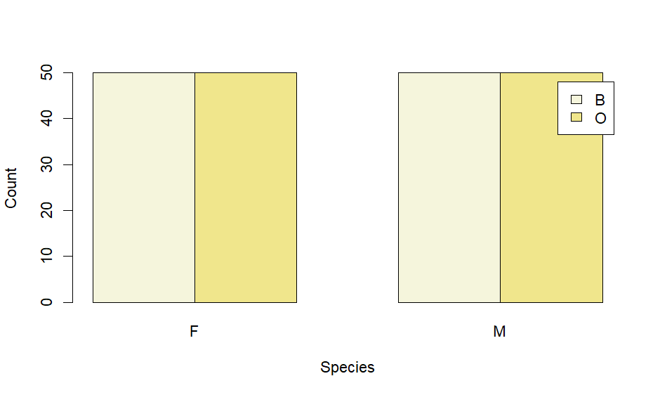
Bar Chart of Species
- Comment on whether the dataset is balanced across the four groups.
The crabs dataset is balanced across the four groups because each combination of species and sex (Blue Male, Blue Female, Orange Male, and Orange Female) contains an equal number of observations (50 crabs each). This means no group is over-represented, allowing fair comparison and reliable statistical analysis.

QUESTION 2
- Construct side-by-side boxplots of body depth (BD) for the four groups defined by species and sex.
boxplot(BD ~ sp * sex, data = crabs, xlab = "Species and Sex", ylab = "Body Depth (BD)", main = "",col = c("thistle", "maroon", "honeydew", "coral"))

Below is the side by side boxplots of body depth (BD) for the four groups defined by species and sex

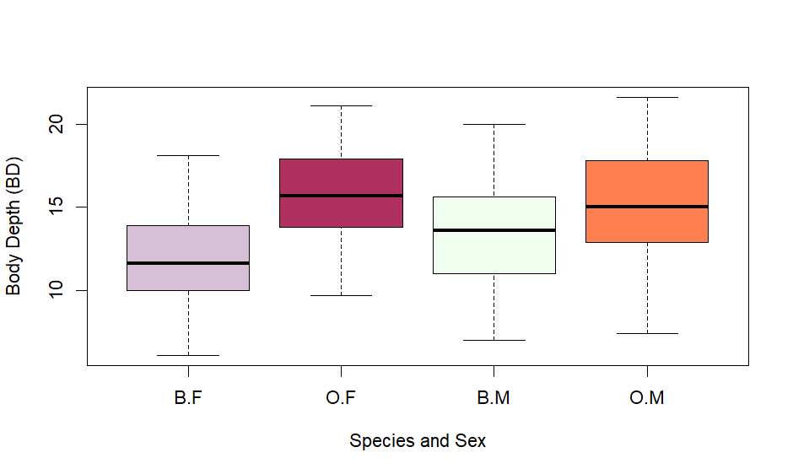
Boxplot of the four groups by species and sex.

- Are they any outliers and compare the central tendency and variability between groups.
By observing the side-by-side boxplots, there are no obvious outliers, since no data points appear far beyond the whiskers of the plots.
The central tendency, shown by the median lines in the boxes, varies across the four groups. In general, male crabs have a higher median body depth than female crabs, and slight differences can also be seen between the two species.
The variability, represented by the width of the boxes and the length of the whiskers, is quite similar among the groups, although a few groups show a slightly larger spread, indicating more variation in body depth.
Overall, from the boxplots, there are no clear unusual values (outliers) in any of the groups. The average body depth differs slightly between the groups, with male crabs generally having deeper bodies than females. However, the amount of variation within each group is quite similar. Overall, the groups show small differences in body depth but a comparable spread of measurements.

QUESTION 3
- Produce histograms of caraspace length (CL) for each species.
hist(crabs$CL[crabs$sp == "B"], main = "", xlab = "Carapace Length (CL)", col = "cadetblue", breaks = 10)

Below is the histogram for blue species.
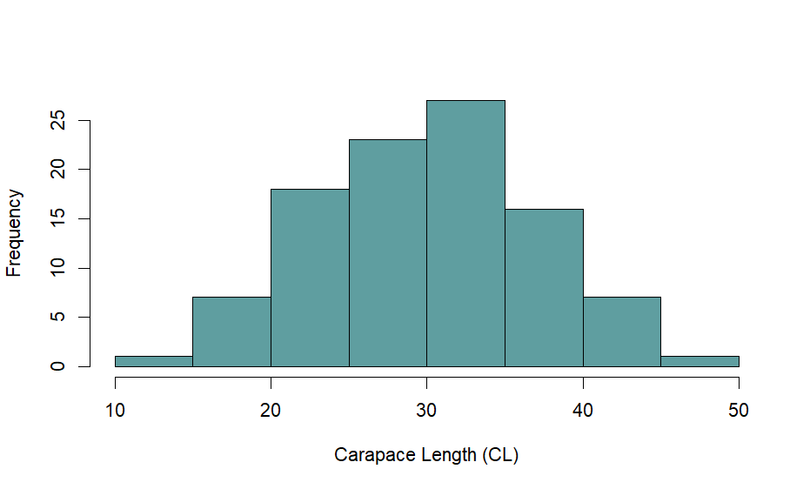
Histogram of Blue Species

hist(crabs$CL[crabs$sp == "O"],
main = "",
xlab = "Carapace Length (CL)",
col = "orange4",
breaks = 10)

Below is the histogram for orange species.
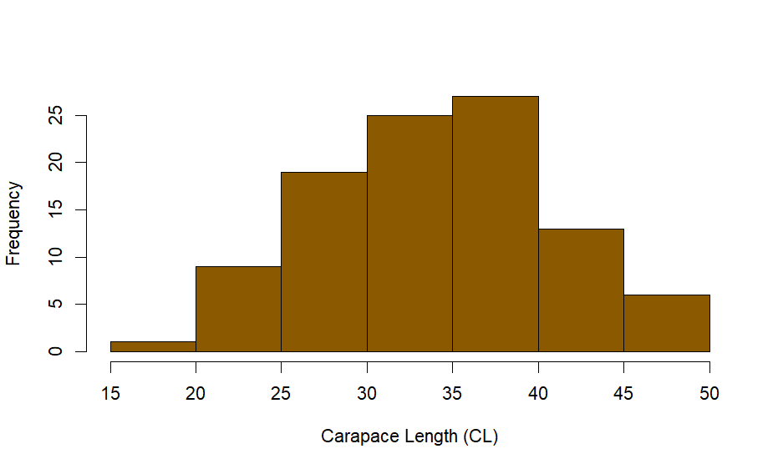
Histogram of Orange Species
- Describe and compare the shapes of the distributions, commenting on skewness and modality.

Blue Species (B): The histogram for the blue crabs looks roughly symmetric, forming a bell-shaped curve. Most of the crabs have carapace lengths around the average, and the distribution has a single clear peak. There are no obvious long tails or extreme values.

Orange Species (O): The histogram for the orange crabs is a little different. It leans slightly to the right, meaning a few crabs have larger carapace lengths. Like the blue crabs, it mostly has one main peak, but there might be a hint of a second smaller peak, suggesting a possible second group of sizes.

Summary: Overall, blue crabs have a fairly even, symmetric distribution of carapace lengths, while orange crabs show a slight tilt to the right and may have some variation suggesting two groups. This shows that carapace lengths can differ between the two species, possibly due to genetics, environment, or other biological factors.
NB: The histograms were only created for the blue (B) and orange (O) species, as the dataset did not contain observations for the green (G) and yellow (Y) species. Therefore, the comparisons and observations are based solely on the blue and orange species.

QUESTION 4
- Compute the mean of each morphological measurement (FL,RW,CL,CW,BD) by species and sex.
mean_ss <- aggregate(cbind(FL, RW, CL, CW, BD) ~ sp + sex, data = crabs, FUN = mean, na.rm = TRUE)
print(mean_ss)

sp sex FL RW CL CW BD
1 B F 13.270 12.138 28.102 32.624 11.816
2 O F 17.594 14.836 34.618 39.036 15.632
3 B M 14.842 11.718 32.014 36.810 13.350
4 O M 16.626 12.262 33.688 37.188 15.324

- Construct a grouped bar chart to display these means.
barplot(t(as.matrix(mean_ss[, 3:7])), beside = TRUE, col = c("oldlace", "mistyrose","tan","orchid","honeydew"), legend = TRUE,
names.arg = paste(mean_ss$sp, mean_ss$sex, sep = "-"), xlab = "Species and Sex", ylab = "Mean Value", main = "")

Below is the grouped bar chart to display the means.

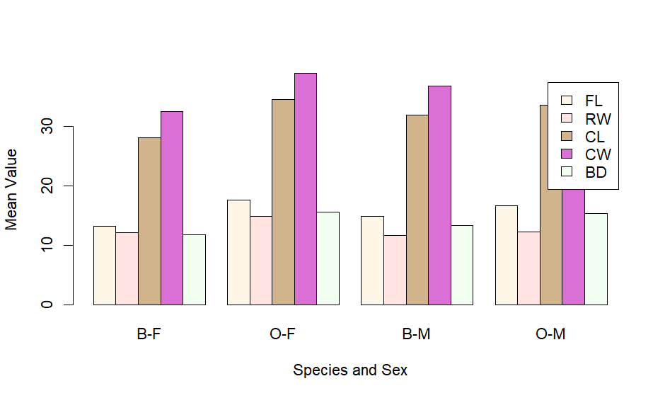

Group Bar Chart of morphological measurement by species and sex.

- Identify which measurement shows the greatest species difference and which shows the least sex variation.

Looking at the mean measurements:
Carapace Length (CL) shows the biggest difference between species, meaning blue and orange crabs have noticeably different sizes here.
Frontal Lobe (FL) shows the smallest difference between sexes, meaning males and females are very similar for this trait.
In short, carapace size separates species the most, while frontal lobe size is almost the same for both sexes.

QUESTION 5
- Produce a scatter plot matrix (pairs plot) of the five measurements.

pairs(crabs[, c("FL", "RW", "CL", "CW", "BD")], main = "", col = 1:4)

Below is the scatter plot of the five measurements.
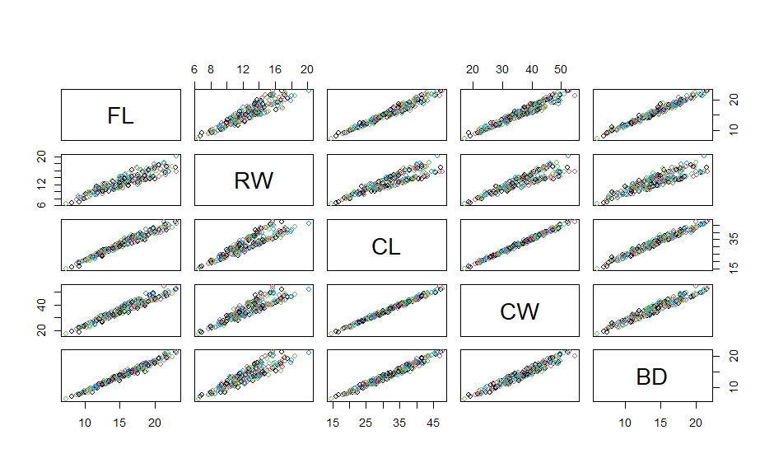
Scatter plot of five measurements.

- Describe the strength and nature of the relationships among variables.
Looking at the scatter plots of the five measurements (FL, RW, CL, CW, BD), most of the variables show strong positive relationships. This means that when one measurement is larger, the others tend to be larger too. For example, crabs with a longer carapace usually also have a wider carapace and deeper bodies.
The relationships look mostly linear, as the points roughly follow straight-line patterns. There are no obvious unusual points or outliers. Overall, the measurements are closely related, showing that bigger crabs tend to be bigger in all body parts.
In short, the scatter plots show that the different body measurements increase together, which makes sense biologically because a larger crab is generally larger in every part of its body.
QUESTION 6
Comprehensive Statistical Report
Analysis of Crab Morphological Measurements
The crabs dataset from the MASS package contains measurements of 200 crabs, divided evenly by species (Blue and Orange) and sex (Male and Female). The dataset includes five morphological traits: Frontal Lobe size (FL), Rear Width (RW), Carapace Length (CL), Carapace Width (CW), and Body Depth (BD). This report examines differences between species and sexes, the distribution of measurements, and the relationships among the traits.
Differences by Species and Sex
A side-by-side boxplot of Body Depth (BD) shows that male crabs tend to have higher body depth than females, while differences between species are also visible. There are no clear outliers, and the variability within each group is fairly consistent. Looking at the means of all five traits confirms these observations. Carapace Length (CL) shows the largest difference between species, while Frontal Lobe size (FL) shows the smallest difference between sexes. A grouped bar chart of the means helps to visualize these patterns clearly, making it easy to compare the groups.
Distribution of Carapace Length
Histograms of CL for the two species show different patterns. The Blue species has a roughly symmetric, bell-shaped distribution, with most crabs close to the average size. The Orange species shows a slight positive skew, meaning a few crabs are larger than the rest. Both species have one main peak, though the Orange crabs hint at a possible second, smaller grouping of sizes.
Relationships Among Measurements
Scatter plots of the five traits reveal strong positive relationships between them. When one measurement increases, the others tend to increase as well. For example, crabs with longer carapaces generally have wider carapaces and deeper bodies. The relationships appear mostly linear, and there are no unusual points disrupting the patterns. This suggests that larger crabs are consistently larger across all body dimensions.
CONCLUSIONS
Overall, the data show clear patterns. Carapace measurements are the most useful for distinguishing species, while sex differences are smaller, particularly in frontal lobe size. The measurements are strongly correlated, so bigger crabs tend to be bigger in all traits. Graphical and numerical analyses together tell a coherent story: crab size differences exist between species and sexes, but all body parts grow together in a predictable way.
In summary, the crabs dataset shows that species differ mainly in carapace size, sex differences are more subtle, and all body measurements are closely linked. The combination of graphs and averages gives a clear picture of crab morphology and highlights both variation and consistency in their body structures.

